GPS Instrument

The instrument displays data from the GPS.

It allows for simple rejection filtering based on SNR, Speed, HDOP, and if the fix is of dgps quality or not.

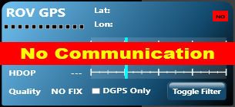

GPS instrument when do data is being send by the GPS or some other comms fault

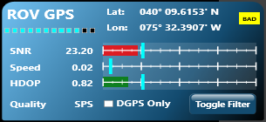

GPS instrument with data being filtered (due to low SNR)

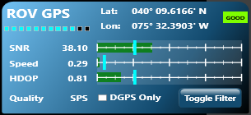

GPS instrument with data being passed

Status:

NO = no data

Bad = data is filtered

Good = data passed filter

Lat/Lon

Satellite count

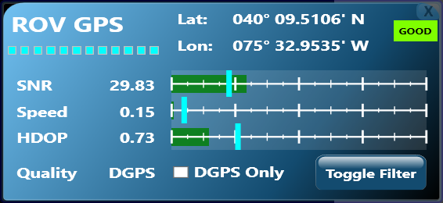

Toggle ALL filters

Toggle Quality filter

Quality indicator

SPS = Standard Position

DGPS = Differential Position

SNR is set from 1 (worst) to 99 (best). Moving the threshold to the LEFT makes the filter weaker (it passes weaker signals)

Speed is in knots. Moving the threshold to the RIGHT makes the filter weaker.

HDOP is in meters. Moving the threshold to the RIGHT makes the filter weaker.

Unchecking DGPS only makes the filter weaker.

The bar charts will turn RED if that specific data does not pass the filter.

Tool tips on the bar charts indicate the threshold settings.

The bounds for the bar charts (and thus the allowable ranges) are set in the instrument config file. There is no UI for those settings at this time.